**Free Falling Eggs**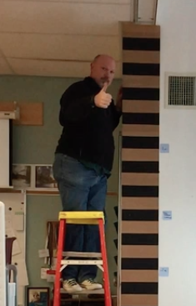

Watch the video of Mr. Nealley dropping an Egg against the “picket fence” in the classroom. We will use this video to analyze the motion of the egg and to learn how to use this tool to study motion.

[Egg Drop Video](https://drive.google.com/open?id=1bkTRQuH2Q5mokB1TTsMNmGTz3Oz5N0G-)

Analyze the video and record your answers in the chart below:

**Displacement** is a fancy way to describe how far something has moved. What is the total displacement of the egg during the freefall?

330 Cm = 3.3m

What is the time on the stop watch when Mr. Nealley releases the egg?

43.75

What is the time on the stop watch when the egg hits the floor?

44.43

How can you calculate the total time it took the egg to fall? What is the elapsed time?

The time is .68 seconds

| Total Displacement (D)  Don’t forget to use units! |  |
| --- | --- |
| Initial Time (Ti) | 43.75 sec |
| Final Time (Tf) | 44.43 sec |
| Free Fall Time (T) | .68 sec |
| Average Velocity of the Egg ( V=D/T) | **Average**= Around  4.85 m/s  **Instantaneous** V=6.665 |

Is the velocity of the egg falling constant during the entire fall? **Justify your answer.**

The velocity of the egg falling is not a constant the entire fall because the egg accelerates as it falls and velocity changes. You can see in the video how near the base of the structure the egg is moving fast (passing more sections) in a shorter amount of time.

What is causing the egg to fall? Gravity

What is the rate that things fall on our planet? 9.8 m/s

**Acceleration**

Going back to the video, analyze the drop and find four positions of the egg against the picket fence. Measure the total displacement of the egg at each point and record the time for each point.

Don’t forget to use your units!

| Displacement | Elapsed time |
| --- | --- |
| 2.8m | .1 sec |
| 2.2m | .27 sec |
| 1.4m | .39sec |
| .3m | .61sec |

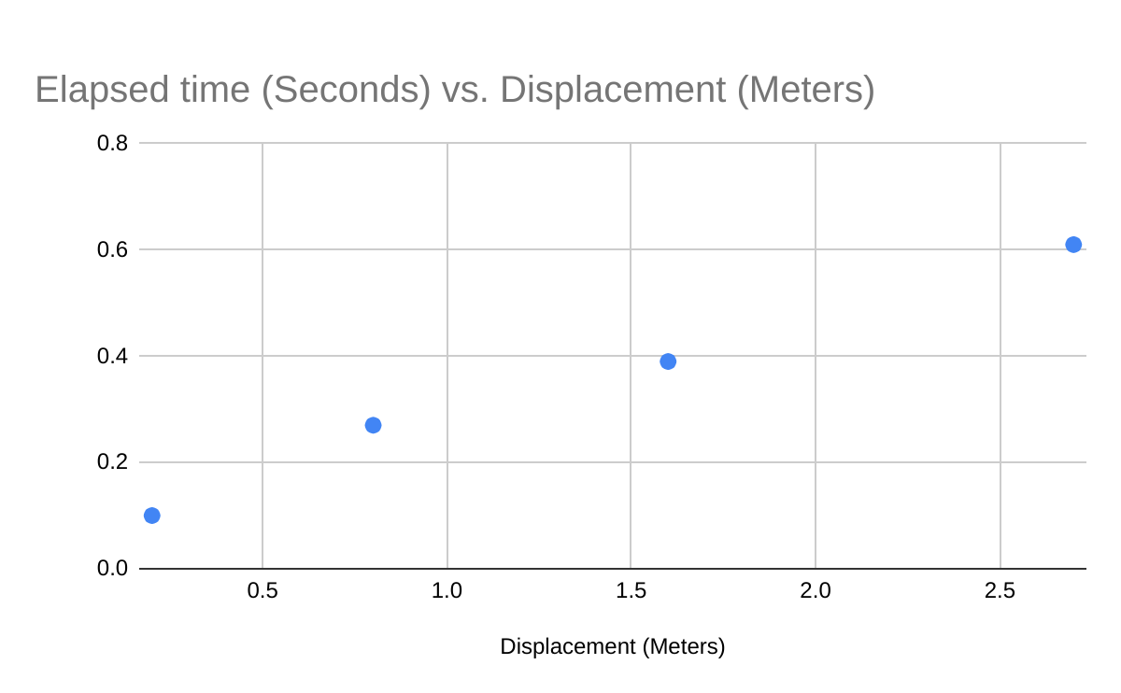

Refer to the [graphing rubric](https://docs.google.com/a/tamdistrict.org/document/d/1ctIEbYgmPBhwJs9QOuEWbqrkIHMB7oZLo-rDcsvvLvw/edit?usp=sharing) to make sure you have all the important parts to your graph.

Putting the time on the X axis and the displacement on the Y axis, graph your 4 points on the graph. What type of line does this graph indicate? This graph indicates more of a linear growth and shows a more constant



We can calculate this using the following formula

Using the data from the table above, calculate the acceleration of the egg in the video.



= v=g(t) v=(9.8)(.68) = 6.664m/s a= (0-6.664) / (44.43 - 43.75) a= (6.664) / (0.68s)  **a= 9.8 m/s²**

What is the known value for acceleration due to gravity on earth?

9.8m/s

Does our value agree with the “known” value for acceleration? Why do you think there might be a difference? Our value is the same as the acceleration of gravity and I believe that if you do the equations and values correctly it will always be 9.8 or in the general range of numbers it will be different because of the wind and air resistance on the ball or human error.